## Project 1

## PetStore Enterprise Data Warehouse

Overview

PetStore is a nationwide seller of pets and merchandize. To separately monitor their inventory, the purchasing department created two databases – Animal Supply and Merchandise Supply. The sales department maintains the customer order fulfillment information in the Sales database. These are standalone databases and mostly perform functions for their own departments with delayed inter-departmental communications. PetStore wants to make all the data accessible to all users to increase visibility across different functions and business processes. You are asked to integrate these databases to create an Enterprise Data Warehouse for PetStore.

## Data Warehouse Business Requirements

As part of the company’s Business Intelligence initiative, PetStore would like to create data marts with the following goals:

***Sales Information***. Senior management would like to be able to track sales of animals and merchandise by customer, employee, and supplier, with the goal of establishing which animals and merchandise are the top sellers which employees place the most orders, and who are the best suppliers.

***Procurement Process***. There is a need to analyze the procurement process to see if the time between when the order is placed and when it is received can be improved. The analysis needs to be done for both animal and merchandise purchases by supplier.

***Product Flow Analysis***. Management requires a means to track each animal from purchase to sold date by supplier, breed, and category. This is essential for the upkeep of the animals with minimum stay in enclosures.

***Sales Coverage Analysis***. Management wants to expand the business by analyzing state wise sales coverage across customer and supplier. Management also want to analyze the sales territories covered by the employees.

***Profitability***. Most importantly, the senior managers want to know the overall profit by animal, merchandise, customer, and employee.

**1. Create an Enterprise Bus Matrix to support the above business requirements**. **(5 points)**

(See attached Excel File. Could not fit screenshot into word document.)

**2. Using SQL Server Management Studio create the enterprise data warehouse by the name PetStoreEDW**. **Identify dimensions, fact tables, and conformed dimensions. Are there any factless fact tables and outriggers? Submit the database diagram of PetStoreEDW**. **(7 points).**

|  |  |  |
| --- | --- | --- |
| **Dimensions** | **Fact tables** | **Conformed Dimensions** |
| Customer | AnimalOrder | Employee |
| Sale | MerchandiseOrder | Supplier |
| Breed | OrderItem | Animal |
| Category | AnimalOrderItem | Merchandise |
| City | SaleItem |  |
|  | SaleAnimal |  |
|  | CustomerAccount |  |

* No factless fact tables

(Tables of database before integration)

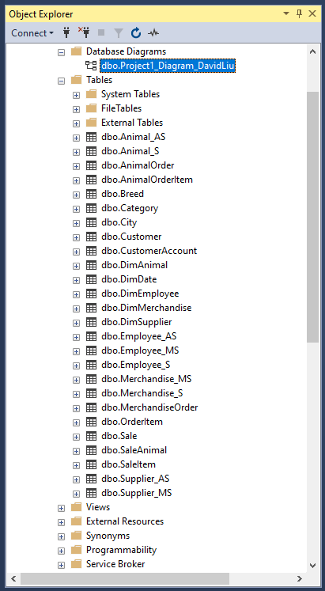

**Codes for Conformed Dimensions**

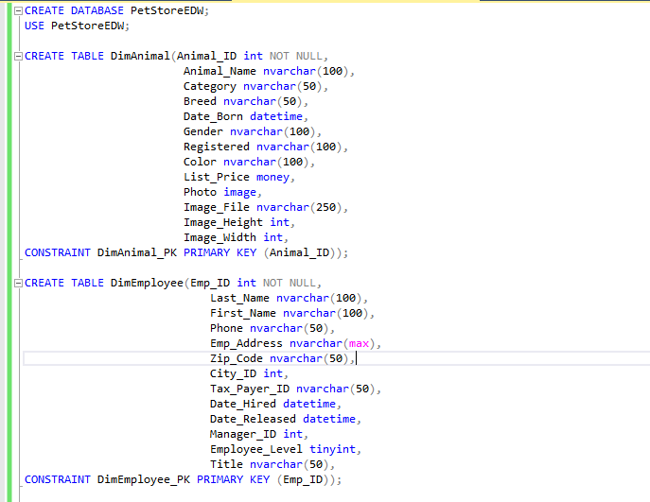

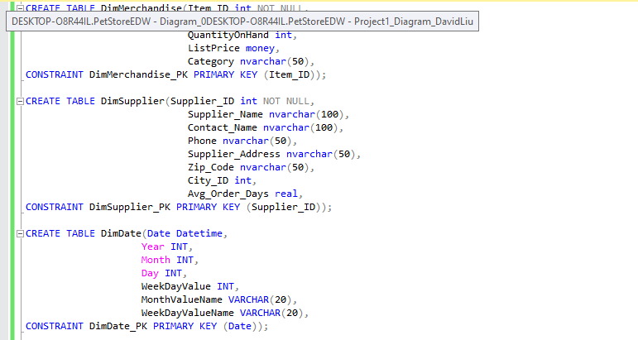

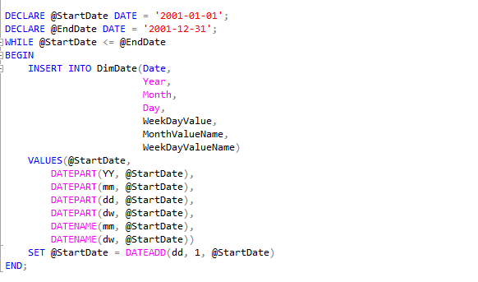

**Data Flow Diagrams For Conformed Dimensions**

(Animal and Employee dimension did not actually need to merge since Animals from Sales database and Employee from Sales database are supersets to Animal and Employee in other databases, but I found it more simple to handle by changing their table and (some) variable names)

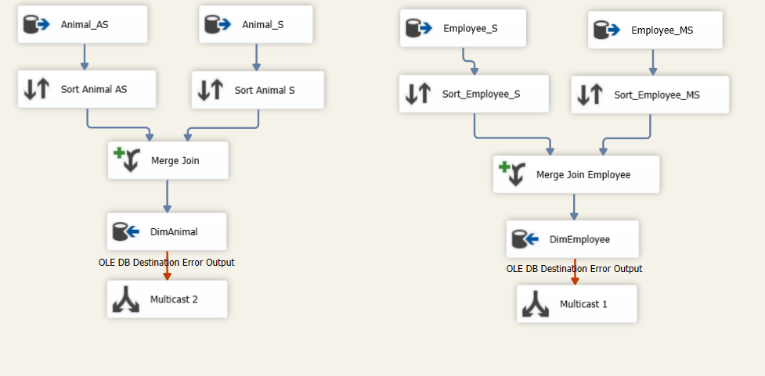

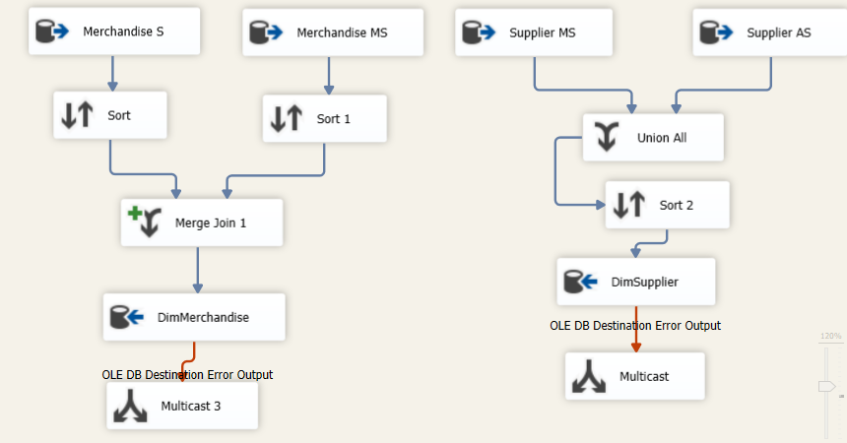

**CONFORMED DIAGRAM**

(I attached a separate version screenshotted on a word file)



**3. Create separate OLAP cubes using only the relevant dimensions and fact tables required for the following queries. Take screenshots of the cube structures and dimensional usages after successfully deploying the cube. While creating the cube, also create following new calculated members if required:**

(Data Source of all relevant tables)

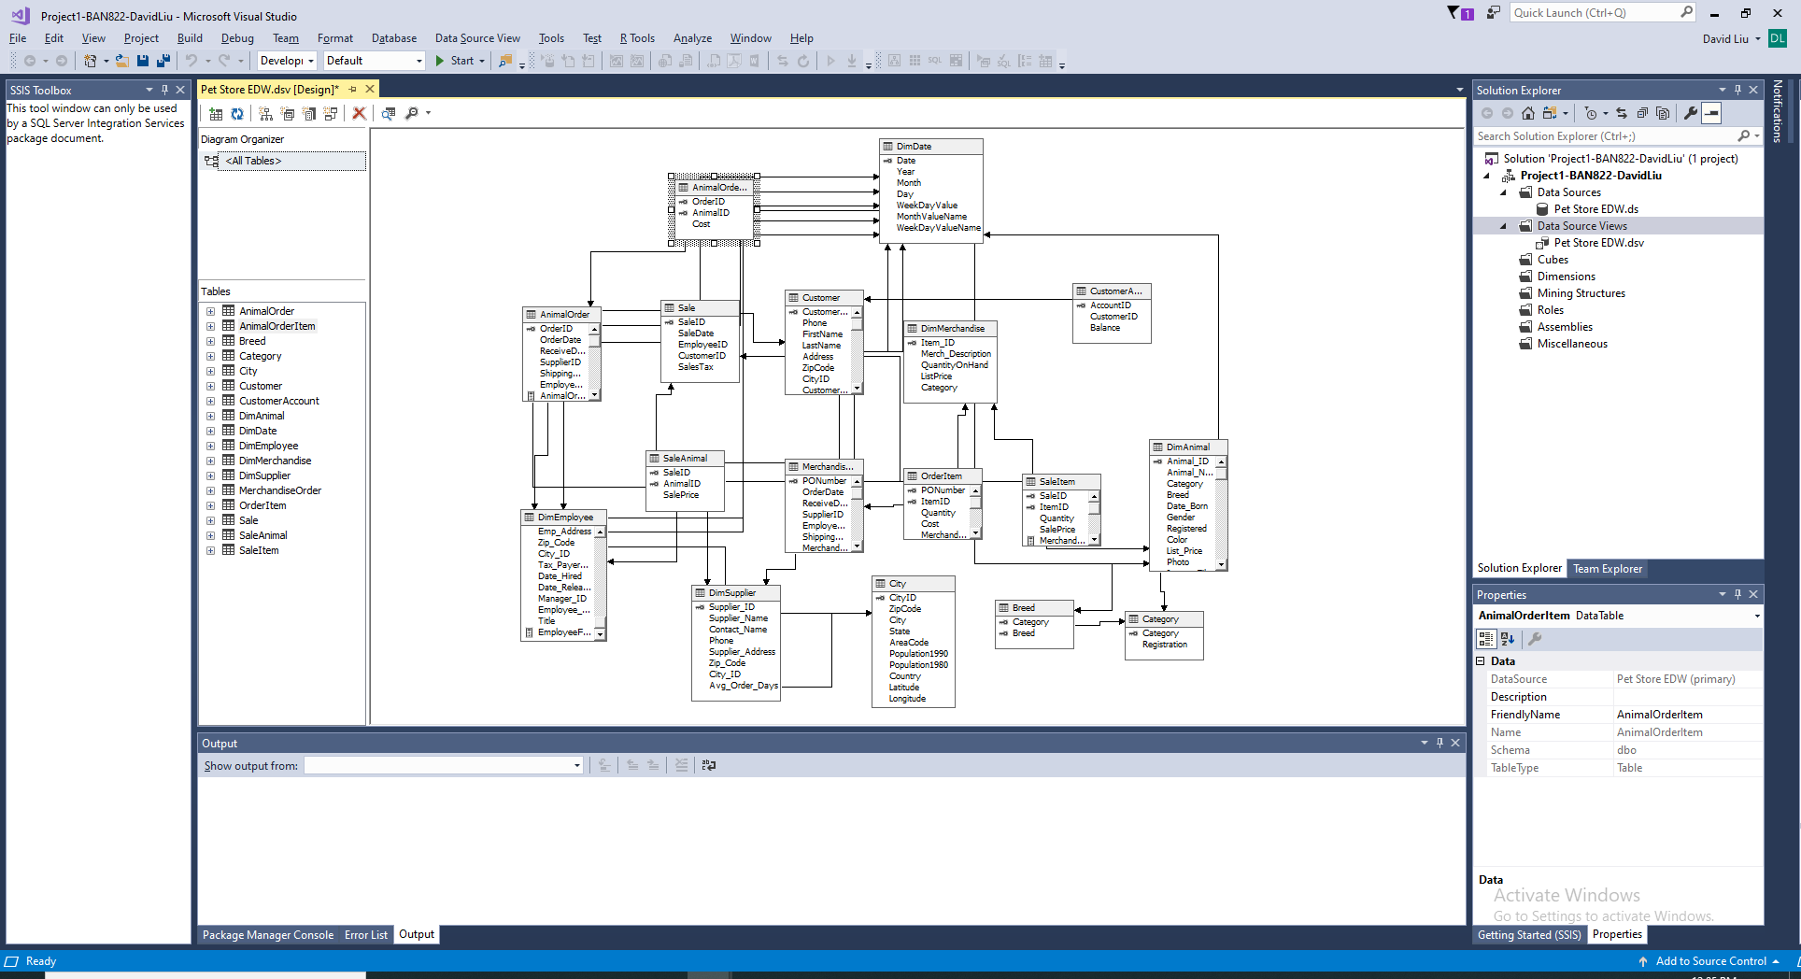

* **AnimalOrderToReceiveTime in the AnimalOrder table**

(Codes to incorporate the new calculated column)

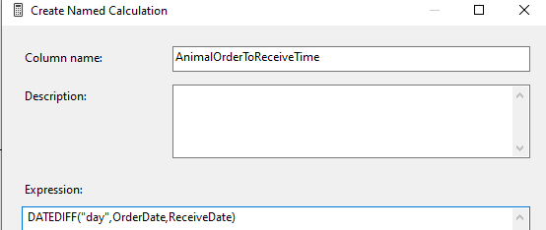

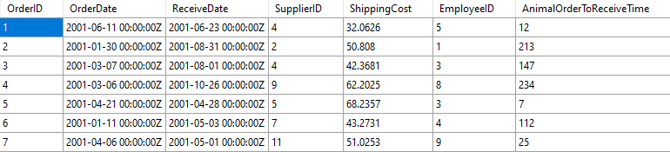

* **MerchandiseOrderToReceiveTime in the MerchandiseOrder table**

(Codes to incorporate the new calculated column)

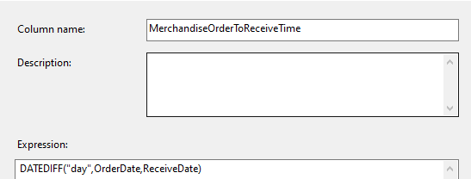

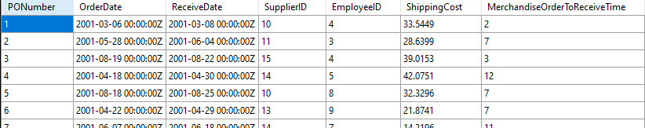

* **CustomerFullName in Customer table**

(Codes to incorporate the new calculated column)

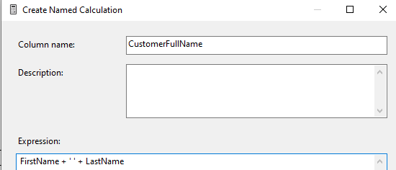

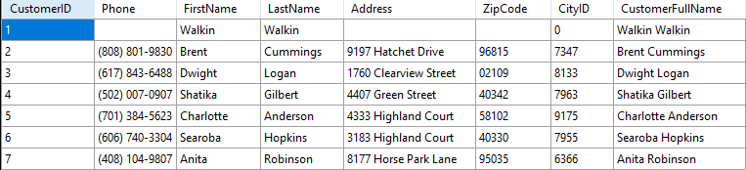

* **EmployeeFullName in DimEmployee table**

(Codes to incorporate the new calculated column)

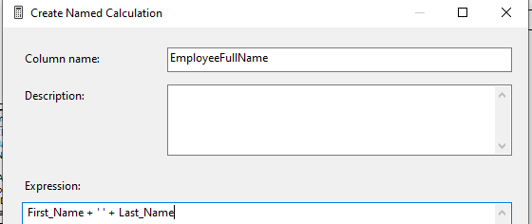

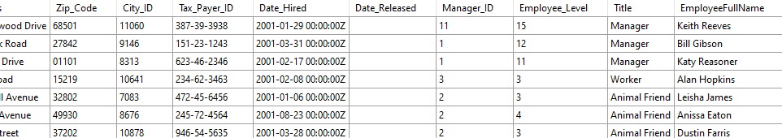

* **MerchandiseCostAmount i.e. Quantity times Cost in OrderItem table**

(Codes to incorporate the new calculated column)

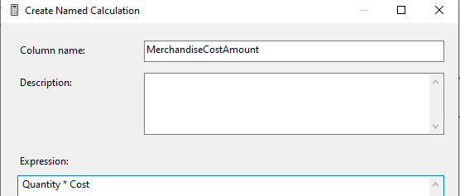

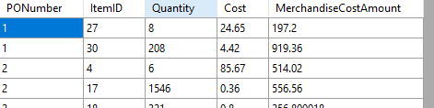

* **MerchandiseSaleAmount i.e. Quantity time SalePrice in SaleItem table**

(Codes to incorporate the new calculated column)

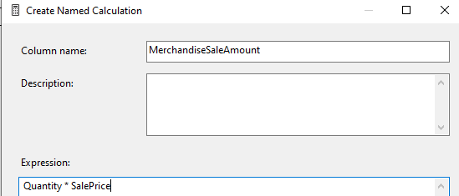

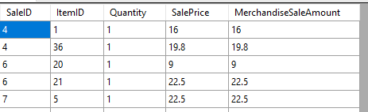

**Create following reports using MDX query to drill across fact tables:**

1. **Sales By Customer (1 point):** Display the animal sale price, sales tax, merchandise sale amount, and customer balance for each customer. Will you use Sale table as fact or dimension or both in the cube? Explain.

* Sale table served as both the fact and dimension table. The Sale table contains the ‘Sale Price’ column, which is a measure that was needed to answer this question. However, it was also needed as a dimension in order to incorporate the ‘SaleAnimal’ table into the OLAP cube.

(Cube Structure of Sales By Customer Cube)

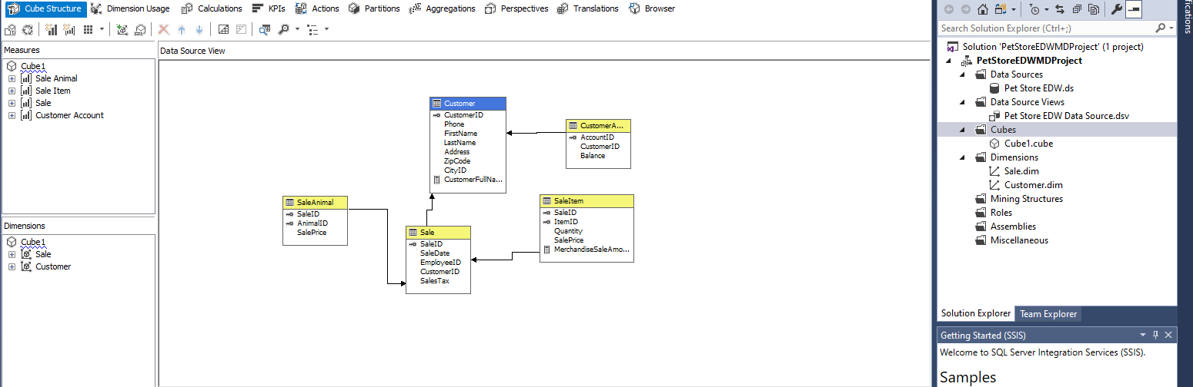

(Cube Dimension Usage of Sales By Customer Cube)

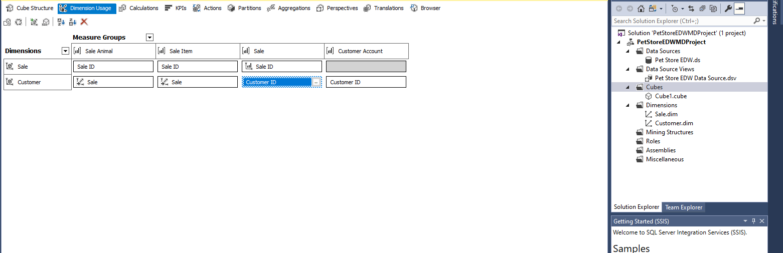

(MDX query for Sales By Customer)

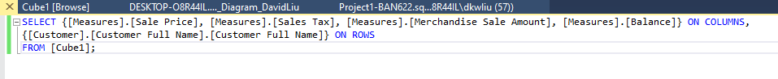

(Result of MDX query)

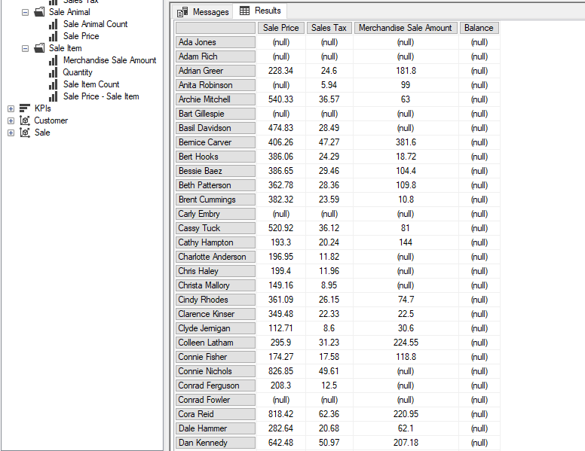

1. **Shipping costs By Supplier (1 point):** Display the shipping cost for animals and merchandise for each supplier.

(Cube Structure of Shipping costs By Supplier Cube)

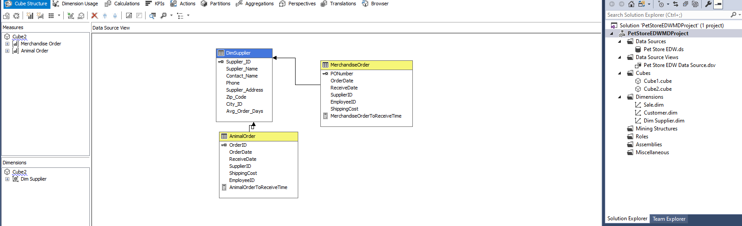

(Cube Dimension Usage of Shipping costs By Supplier Cube)

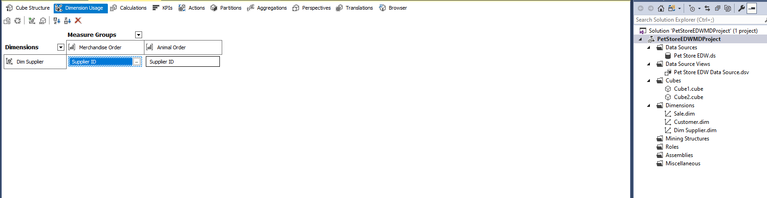

(MDX query for Shipping costs By Supplier)



(Result of MDX query)

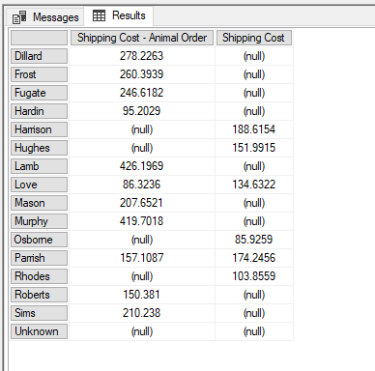

1. **Difference between list and sale prices By AnimalID (1 point):** Display the list price, sale price, and the difference of list and sale prices for each Animal ID.

(Cube Structure of Difference between list and sale prices By AnimalID Cube)

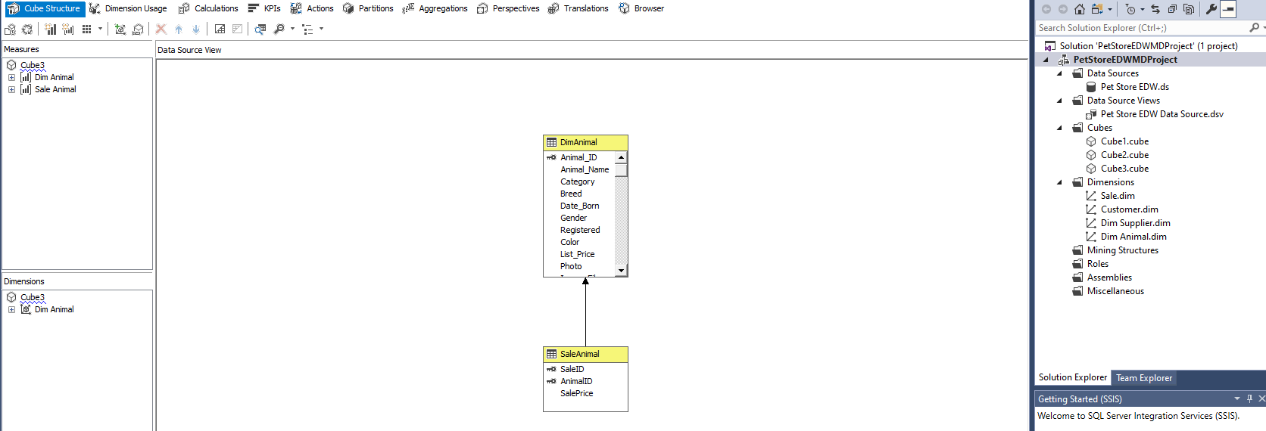

(Cube Dimension Usage of Difference between list and sale prices By AnimalID Cube)

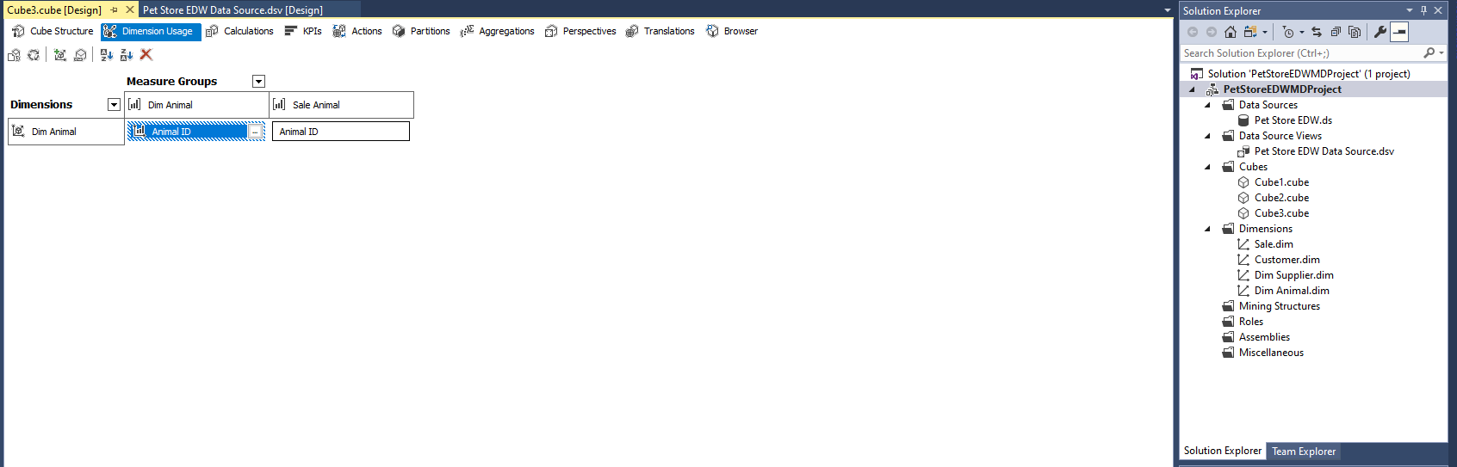

(MDX query for Difference between list and sale prices By AnimalID)

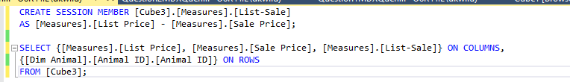

(Result of MDX query)

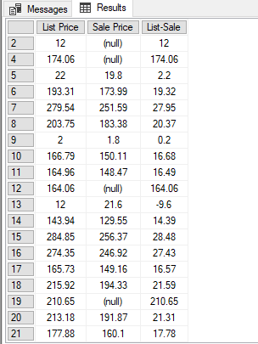

**Submission Guidelines**

Submit the bus matrix, enterprise data warehouse diagram, cube structures, dimensional usage, relevant screenshots, MDX queries and answers in Blackboard.